Name : Samarth Udagi

MIS – 112315160

Assignment -1

\*\*\*\*\*\*\*\*\*\*\*\*\*\*\*\*\*\*\*\*\*\*\*\*\*

1). Write Python Program to get Python version you are using

Code :

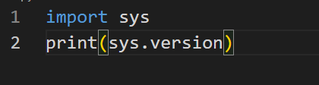

Output:



2)Write a python program to list all Keyword in Python .

Code :

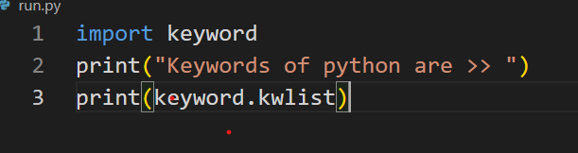

Output:



3).Take age and Name input,print out a message addressed to them that tells them the year that they will turn 100 years old

Code :

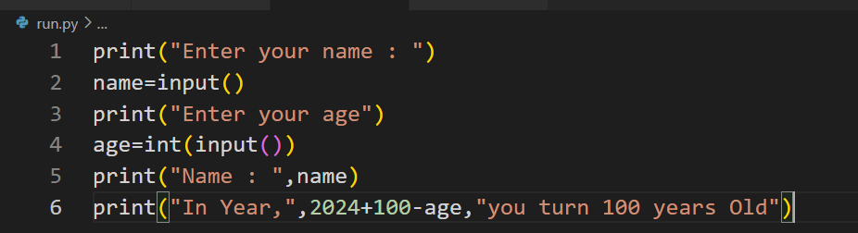

Output:

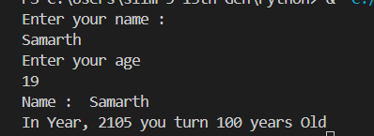

4). Write a program which accepts the radius of a circle from user and compute the area.

Code :

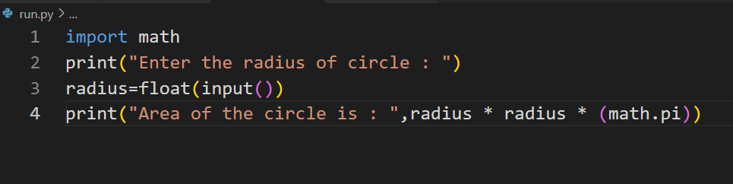

Output:

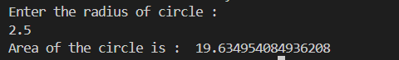

5). Ask User a Number. Depending on wheather the number is even or odd, print out appropriate message to the user.

Code :

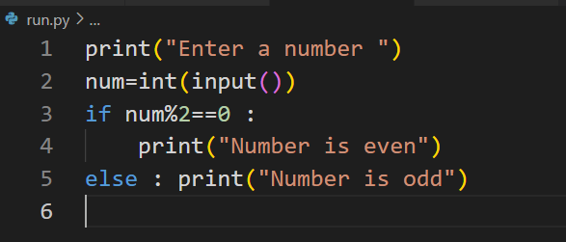

Output:

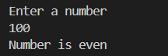

6).Check Whether 0.1+0.2=0.3 holds True in python? If not find the way to make it True

Code :

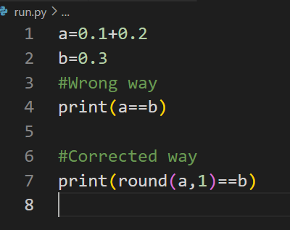

Output:



7).write a python program to get a single string from two given strings, separated by a space and swap the first two character of each string

Code :

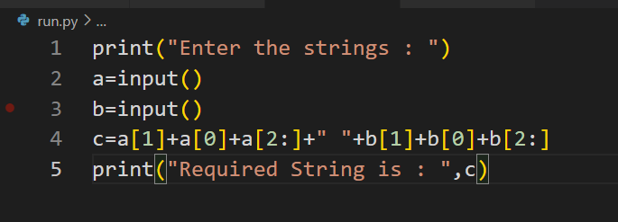

Output:

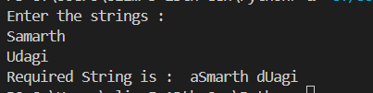

8). Ask the user for a string containing lowercase letters, digits or underscores or combination of all. Write a python to check whether the string is a valid identifier

Code :

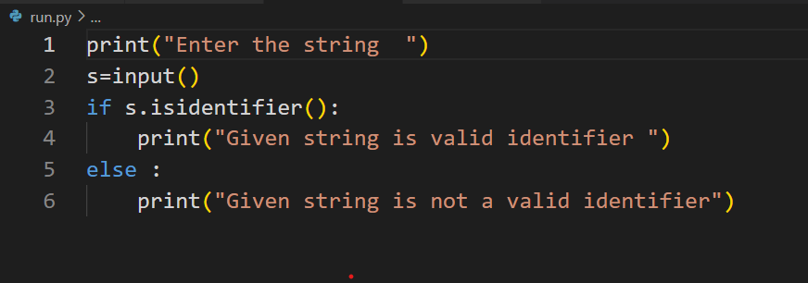

Output:

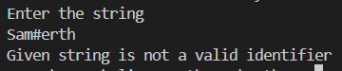

9).Write Python program to change a given string to a new string where the 1st and last chars have   been exchanged

Code :

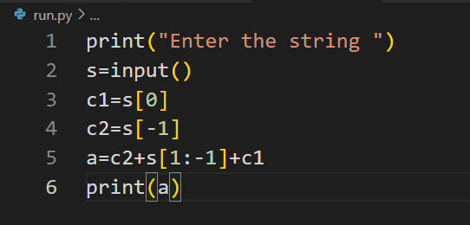

Output:

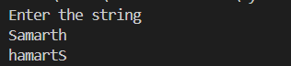

10).Write a Python script that takes input from the user and display that input back in upper and lower cases.

Code :

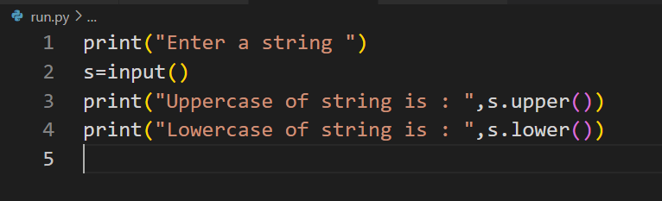

Output:

